ALPHA ARTS AND SCIENCE COLLEGE

STUDENT SATISFACTION SURVEY REPORT 2020-2021

- How much of the syllabus was covered in the class?

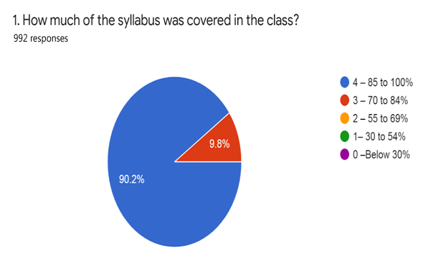

- How well did the teachers prepare for the classes?

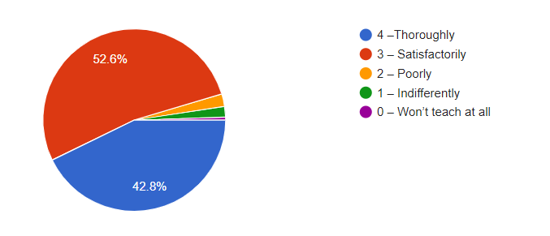

- How well were the teachers able to communicate?
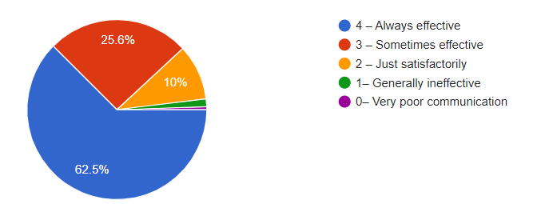

- The teacher’s approach to teaching can best be described as

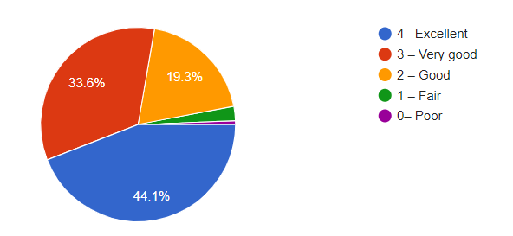
- Fairness of the internal evaluation process by the teachers.

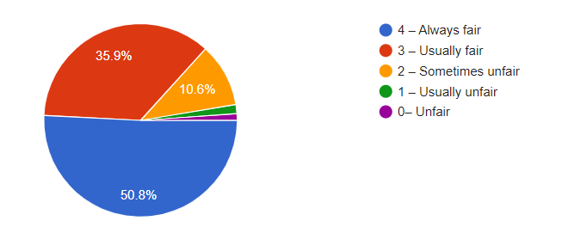
- Was your performance in assignments discussed with you?
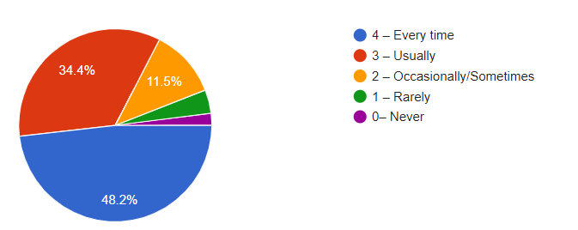

- The institute takes active interest in promoting internship, student exchange, field visit opportunities for students.
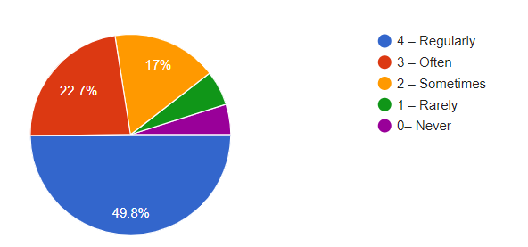

- The teaching and mentoring process in your institution facilitates you in cognitive, social and emotional growth.
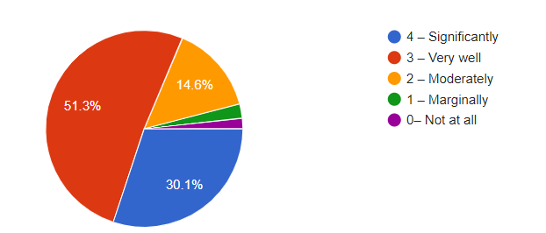
- The institution provides multiple opportunities to learn and grow.
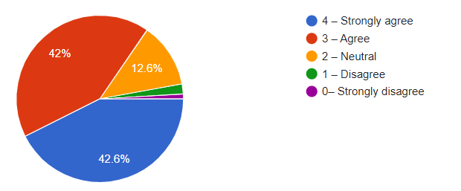

- Teachers inform you about your expected competencies, course outcomes and programme outcomes.
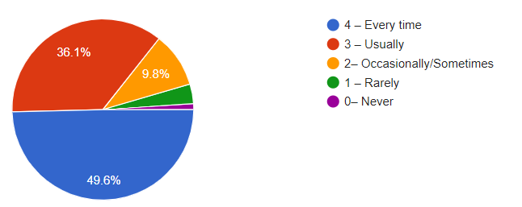

- Your mentor does a necessary follow-up with an assigned task to you.
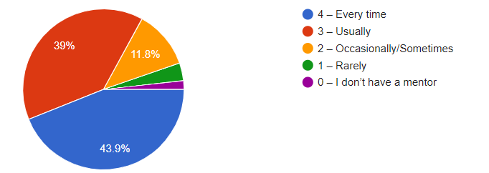

- The teachers illustrate the concepts through examples and applications.
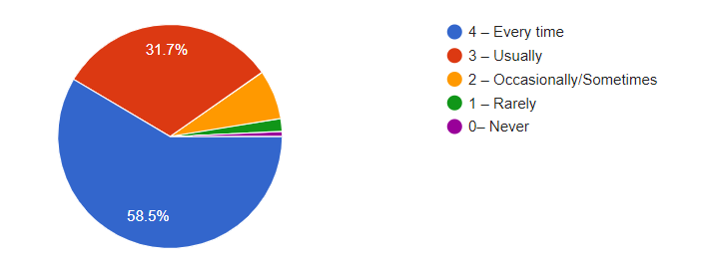

- The teachers identify your strengths and encourage you with providing right level of challenges.
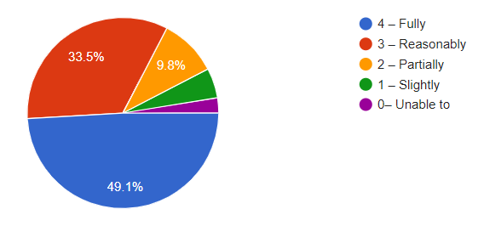

- Teachers are able to identify your weaknesses and help you to overcome them.
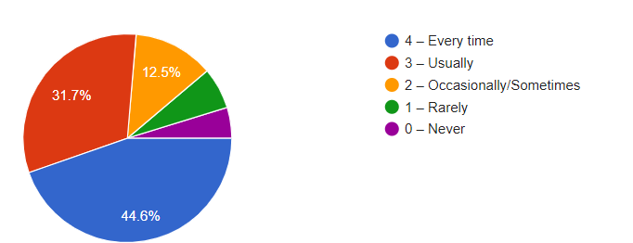

- The institution makes effort to engage students in the monitoring, review and continuous quality improvement of the teaching learning process.
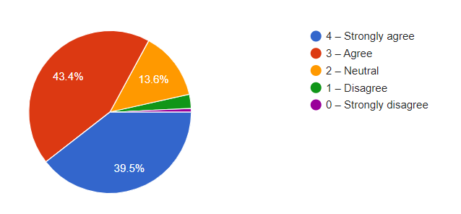

- The institute/ teachers use student centric methods, such as experiential learning, participative learning and problem solving methodologies for enhancing learning experiences.
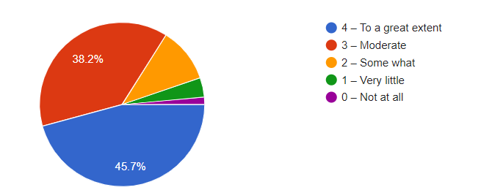

- Teachers encourage you to participate in extracurricular activities.
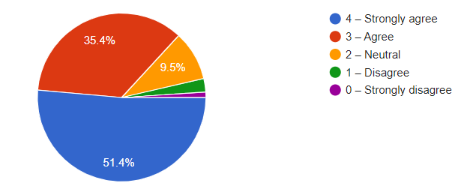

- Efforts are made by the institute/ teachers to inculcate soft skills, life skills and employability skills to make you ready for the world of work.

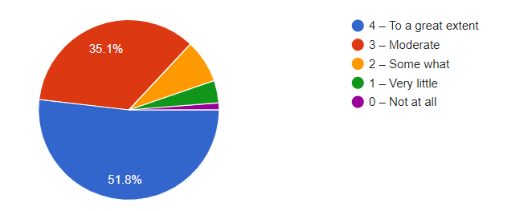

- What percentage of teachers use ICT tools such as LCD projector, Multimedia, etc. while teaching.
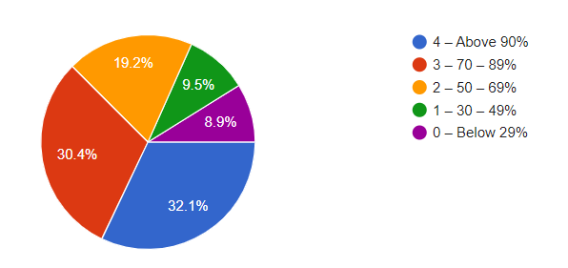

- The overall quality of teaching-learning process in your institute is very good.
